**Analytical SQL Lab**

**Lab instructions:**

Login to <https://livesql.oracle.com/apex/f?p=590:1000> and run the following script to create the table and insert the data that you will be working on during the first part of this lab.

**CREATE** **TABLE** cats (

**NAME** varchar2(40),

breed varchar2(40),

weight NUMBER,

color varchar2(40),

age NUMBER

)**;**

**INSERT** **INTO** cats **VALUES**('Ashes', 'Persian', 4.5, 'Black', 5)**;**

**INSERT** **INTO** cats **VALUES**('Molly', 'Persian', 4.2, 'Black', 1)**;**

**INSERT** **INTO** cats **VALUES**('Felix', 'Persian', 5.0, 'Tortoiseshell', 2)**;**

**INSERT** **INTO** cats **VALUES**('Smudge', 'British Shorthair', 4.9, 'Black', 4)**;**

**INSERT** **INTO** cats **VALUES**('Tigger', 'British Shorthair', 3.8, 'Tortoiseshell', 2)**;**

**INSERT** **INTO** cats **VALUES**('Alfie', 'Siamese', 5.5, 'Brown', 5 )**;**

**INSERT** **INTO** cats **VALUES**('Oscar', 'Siamese', 6.1, 'Black', 1)**;**

**INSERT** **INTO** cats **VALUES**('Millie', 'Maine Coon', 5.4, 'Tortoiseshell', 5)**;**

**INSERT** **INTO** cats **VALUES**('Misty', 'Maine Coon', 5.7, 'Brown', 2)**;**

**INSERT** **INTO** cats **VALUES**('Puss', 'Maine Coon', 5.1, 'Tortoiseshell', 2)**;**

**INSERT** **INTO** cats **VALUES**('Smokey', 'Maine Coon', 6.1, 'Brown', 4)**;**

**INSERT** **INTO** cats **VALUES**('Charlie', 'British Shorthair', 4.8, 'Black', 4)**;**

1. Cats are vain. Each cat would like to pretend it has the lowest weight for its color.

Print cat name, color and the minimum weight of cats with that color.

Return: name, color, lowest_weight_by_color  
Order by: color, name

SELECT NAME, WEIGHT, COLOR ,

MIN(WEIGHT) OVER(PARTITION BY COLOR ORDER BY WEIGHT)

FROM CATS

ORDER BY COLOR,NAME;

--another answer

SELECT NAME, WEIGHT, COLOR ,

first_value(WEIGHT) OVER(PARTITION BY COLOR ORDER BY WEIGHT)

FROM CATS

ORDER BY COLOR,NAME;

1. Cats are fickle. Each cat would like to lose weight according to their breed. Each cat would like to lose weight to be the equivalent weight of the cat in the same breed weighing just less than it.

Print a list of cats, their breeds, weights and the weight difference between them and the nearest lighter cat of the same breed.

Return: name, breed, weight, weight_to_lose  
Order by: weight

SELECT NAME, BREED, WEIGHT,

COALESCE( WEIGHT - LAG(WEIGHT ,1) OVER(PARTITION BY BREED ORDER BY WEIGHT), 0 )AS WEIGHT_TO_LOSE

FROM CATS

ORDER BY WEIGHT;

--another answer

SELECT name, breed, weight,

COALESCE( cast( WEIGHT - LAG(WEIGHT ,1) OVER(PARTITION BY BREED ORDER BY WEIGHT) as varchar(25)), 'no need to lose weight' )AS WEIGHT_TO_LOSE

FROM CATS

ORDER BY WEIGHT;

1. Each cat would like to see the next heaviest cat's weight when grouped by breed. If there is no heavier cat print 'fattest cat'.

Print a list of cats, their weights and either the next heaviest cat's weight or 'fattest cat'.

Return: name, weight, breed, next_heaviest  
Order by: weight

SELECT NAME, WEIGHT, BREED,

COALESCE(TO_CHAR (LEAD(WEIGHT, 1) OVER (PARTITION BY BREED ORDER BY WEIGHT )), 'FATTEST_CAT') AS NXT_HAVIEST_CAT

FROM CATS

order by WEIGHT DESC, BREED DESC

1. The cats have decided the correct weight is the same as the 4th lightest cat. All cats shall have this weight. Except in a fit of jealous rage they decide to set the weight of the lightest three to 99.9.

Print a list of cats, their weights and their imagined weight.

Return: name, weight, imagined_weight  
Order by: weight

SELECT NAME, BREED, WEIGHT ,

COALESCE ( NTH_VALUE(WEIGHT, 4) FROM FIRST OVER(ORDER BY WEIGHT), 99.9)AS IMAGINED_WEIGHT

FROM CATS

ORDER BY WEIGHT;

1. We would like to group our cats by color.

Return 3 rows, each row containing a color and a list of cat names.

Return: color, names Order by: color DESC

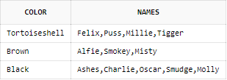

SELECT DISTINCT COLOR,

LISTAGG(NAME, ',') WITHIN GROUP(ORDER BY NAME) OVER(PARTITION BY COLOR) AS NAMES

FROM CATS

ORDER BY COLOR;

1. Consider cats with the same breed and color to be duplicate rows.

Return one row for cats from the same breed and having the same color.

SELECT NAME, WEIGHT, COLOR, BREED

FROM (SELECT NAME, WEIGHT, COLOR, BREED,

ROW_NUMBER () OVER (PARTITION BY BREED, COLOR ORDER BY BREED) AS ROW_NUM

FROM CATS)

WHERE ROW_NUM = 1;

1. Count the number of unique breeds in two different ways.

SELECT NAME, BREED, WEIGHT, COLOR, AGE,

COUNT(DISTINCT BREED) OVER () AS UNIQUE_COUNT

FROM CATS

ORDER BY NAME, BREED;

--ANOTHER ANSWER

select NAME, BREED, WEIGHT, COLOR, AGE , Max(rk) over ()  
from(  
SELECT NAME, BREED, WEIGHT, COLOR, AGE,  
  dense_rank() over(order by BREED) as rk  
    FROM CATS);

Return new column with the count.

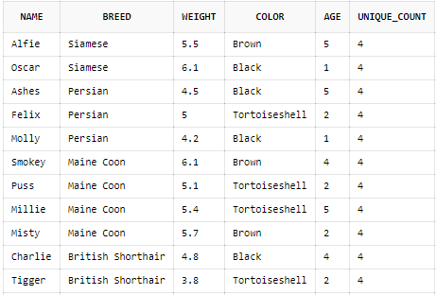

Create another detailed table that holds the dates when the weight of the cats was recorded.

**CREATE** **TABLE** cats_details (

**NAME** varchar2(40),

breed varchar2(40),

weight NUMBER,

color varchar2(40),

age NUMBER ,

weight_recording_dt DATE

)**;**

**INSERT** **INTO** cats_details **VALUES**('Ashes', 'Persian', 4.5, 'Black', 5, To_Date('2020-03-01', 'YYYY-MM-DD'))**;**

**INSERT** **INTO** cats_details **VALUES**('Molly', 'Persian', 4.2, 'Black', 1, To_Date('2020-03-02', 'YYYY-MM-DD'))**;**

**INSERT** **INTO** cats_details **VALUES**('Felix', 'Persian', 5.0, 'Tortoiseshell', 2, To_Date('2020-03-03', 'YYYY-MM-DD'))**;**

**INSERT** **INTO** cats_details **VALUES**('Smudge', 'British Shorthair', 4.9, 'Black', 4, To_Date('2020-03-04', 'YYYY-MM-DD'))**;**

**INSERT** **INTO** cats_details **VALUES**('Tigger', 'British Shorthair', 3.8, 'Tortoiseshell', 2, To_Date('2020-03-05', 'YYYY-MM-DD'))**;**

**INSERT** **INTO** cats_details **VALUES**('Alfie', 'Siamese', 5.5, 'Brown', 5, To_Date('2020-03-06', 'YYYY-MM-DD'))**;**

**INSERT** **INTO** cats_details **VALUES**('Ashes', 'Persian', 5.1, 'Black', 5, To_Date('2020-03-03', 'YYYY-MM-DD'))**;**

**INSERT** **INTO** cats_details **VALUES**('Molly', 'Persian', 4.4, 'Black', 1, To_Date('2020-03-04', 'YYYY-MM-DD'))**;**

**INSERT** **INTO** cats_details **VALUES**('Felix', 'Persian', 5.2, 'Tortoiseshell', 2, To_Date('2020-03-06', 'YYYY-MM-DD'))**;**

**INSERT** **INTO** cats_details **VALUES**('Oscar', 'Siamese', 6.1, 'Black', 1, To_Date('2020-03-01', 'YYYY-MM-DD'))**;**

**INSERT** **INTO** cats_details **VALUES**('Millie', 'Maine Coon', 5.4, 'Tortoiseshell', 5, To_Date('2020-03-02', 'YYYY-MM-DD'))**;**

**INSERT** **INTO** cats_details **VALUES**('Misty', 'Maine Coon', 5.7, 'Brown', 2, To_Date('2020-03-03', 'YYYY-MM-DD'))**;**

**INSERT** **INTO** cats_details **VALUES**('Puss', 'Maine Coon', 5.1, 'Tortoiseshell', 2, To_Date('2020-03-04', 'YYYY-MM-DD'))**;**

**INSERT** **INTO** cats_details **VALUES**('Smokey', 'Maine Coon', 6.1, 'Brown', 4, To_Date('2020-03-05', 'YYYY-MM-DD'))**;**

**INSERT** **INTO** cats_details **VALUES**('Charlie', 'British Shorthair', 4.8, 'Black', 4, To_Date('2020-03-06', 'YYYY-MM-DD'))**;**

**INSERT** **INTO** cats_details **VALUES**('Ashes', 'Persian', 5.0, 'Black', 5, To_Date('2020-03-02', 'YYYY-MM-DD'))**;**

**INSERT** **INTO** cats_details **VALUES**('Molly', 'Persian', 4.0, 'Black', 1, To_Date('2020-03-01', 'YYYY-MM-DD'))**;**

**INSERT** **INTO** cats_details **VALUES**('Felix', 'Persian', 5.0, 'Tortoiseshell', 2, To_Date('2020-03-10', 'YYYY-MM-DD'))**;**

**INSERT** **INTO** cats_details **VALUES**('Smudge', 'British Shorthair', 3.1, 'Black', 4, To_Date('2020-03-01', 'YYYY-MM-DD'))**;**

**INSERT** **INTO** cats_details **VALUES**('Tigger', 'British Shorthair', 2.8, 'Tortoiseshell', 2, To_Date('2020-03-15', 'YYYY-MM-DD'))**;**

1. Transform the above table from transactional to historical table.

SELECT NAME,

BREED, WEIGHT,COLOR,AGE,FIRST_DATE,LAST_DATE,

ABS (LAST_WEIGHT - FIRST_WEIGHT) AS WEIGHT_DIFF

FROM (SELECT NAME,

BREED,

WEIGHT,

COLOR,

AGE,

FIRST_VALUE (WEIGHT_RECORDING_DT)

OVER (PARTITION BY name ORDER BY weight_recording_dt)

AS FIRST_DATE,

LAST_VALUE (

weight_recording_dt)

OVER (

PARTITION BY name

ORDER BY weight_recording_dt

ROWS BETWEEN UNBOUNDED PRECEDING AND UNBOUNDED FOLLOWING)

AS LAST_DATE,

FIRST_VALUE (weight)

OVER (PARTITION BY name ORDER BY weight_recording_dt)

AS FIRST_WEIGHT,

LAST_VALUE (

weight)

OVER (

PARTITION BY name

ORDER BY weight_recording_dt

ROWS BETWEEN UNBOUNDED PRECEDING AND UNBOUNDED FOLLOWING)

AS LAST_WEIGHT,

ROW_NUMBER () OVER (PARTITION BY name ORDER BY name) ROW_NUM

FROM Cats_details)

WHERE ROW_NUM = 1;

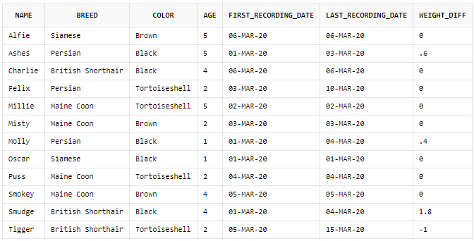

1. Healthy cats keep track of their weight daily.

Return the names of the healthy cats.

SELECT DISTINCT NAME , HEALTHY_COUNT

FROM (

SELECT NAME,

COUNT(*) OVER (PARTITION BY NAME ORDER BY weight_recording_dt RANGE BETWEEN CURRENT ROW AND INTERVAL '1' DAY FOLLOWING) HEALTHY_COUNT

FROM Cats_details)

Where HEALTHY_COUNT>1;

SELECT DISTINCT NAME,

COALESCE(NEXT_DATE-WEIGHT_RECORDING_DT, 0) AS DAYS_DIFF FROM

( SELECT NAME, WEIGHT_RECORDING_DT, LEAD(WEIGHT_RECORDING_DT,1) OVER (PARTITION BY NAME ORDER BY WEIGHT_RECORDING_DT) AS NEXT_DATE FROM CATS_DETAILS)

WHERE COALESCE(NEXT_DATE-WEIGHT_RECORDING_DT, 0) = 1;